Think Like a Historian at the Jonathan Clark House
- A Guide for Young Visitors -

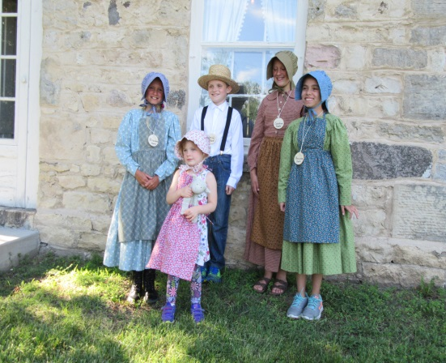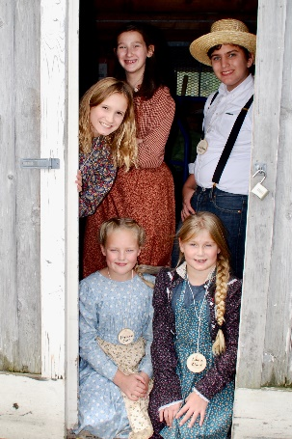

From where did the early Mequon and Thiensville settlers come?
Why did they come to the Mequon Thiensville area?
What did they do when they arrived?
What was life like for the new settlers?
What animals did they have on their farms?
What were the daily chores of the children?
How was their life very different from your family?
How was their life similar to your family?

The answers to these questions can be discovered as you tour the Jonathan Clark House and experience first-hand the lifestyle of the early settlers.

Jonathan Clark was born in 1812 in northern Vermont. At age 21 he enlisted in the US Army. He was stationed in Wisconsin at Fort Howard (now known as Green Bay) where his troop was assigned to expand the small fort and to build the military road from the fort to Fond du Lac.

When Jonathan settled in Mequon in 1839 he purchased 80 acres. In 1843 he and Mary purchased another 80 acres creating a large 160 acre farm. The land would have been mostly forested with some prairie grasses. Can you imagine how hard they had to work to clear the land to make a home for their family?

In 1840 Jonathan married Mary Turck. They most likely lived in a modest log cabin that he had built. In 1848 when their stone house was built Jonathan and
Mary had four children. By 1857 their family had grown to eight children. (7 girls and 1 boy) This was a lot of work for Mary as she cared for her children, prepared meals, sewed clothing, did laundry and planted and tended the gardens.

In addition, the Clark family had two hired men. The hired man’s bedroom tells the story of the meager space and narrow rope bed used by these hard working men. Can you imagine how busy the Clark household would be with the two hired men, Jonathan, Mary and the eight children?

The typical 1848 farm yard would have the following:
Couple of cows for milk
Team of oxen to pull a plow and to drive a cart to town to the mill
Dozen chickens for eggs and chicken dinner
Herd of a dozen sheep for wool to be traded at the mill
Vegetable garden for eating and preserving food
Herb garden for flavoring food and for medicinal products

The chores of the Clark children were separate for boys and girls.
Boys:
Haul water from the well
Help dad cut, split and haul wood for the wood stove
Help with barn chores
Help with field chores
Help the hired man tend to the live stock
Girls:
Help with cooking and baking
Help with spinning, sewing, mending and laundry
Care for younger children
Pick berries and gather honey in the woods
Collect eggs from the chicken house

The life of the young Clark children was filled with hard work as well as fun with the few neighbors that had also settled in the area. They walked one-half mile to Bonniwell School. They used an outhouse instead of an indoor bathroom and they shared beds in the upper floor of the house. How does this differ from your school and your daily life? Are there some similarities?

We are proud to tell the story of Jonathan Clark because he was not only an ambitious farmer, but he was also a businessman. Along with his father-in-law Peter Turck and friend William Bonniwell, Jonathan worked hard to develop the government of the new township of Mequon. One of their most important accomplishments was the creation of the area’s first public school, Bonniwell School.

Come to the Jonathan Clark House and learn more about our early settlers. You will have an adventure that will have you thinking like a historian.

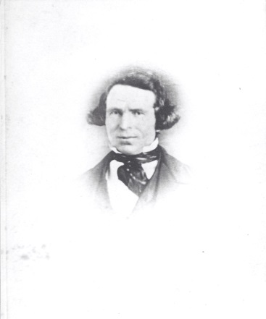 | Jonathan M. Clark  It is possible that Jonathan had this photo taken in about 1856 or shortly before he died in 1857. Can you imagine there would be any other known photos of him at such an early time in the history of photography?
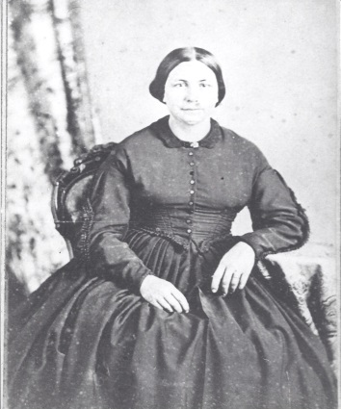 | Mary Turck Clark  Mrs. Clark may have been about 50 years old when this photo was taken. Do you think this was her best outfit?

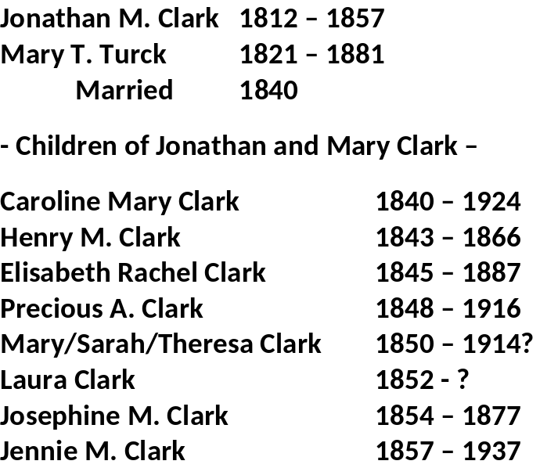 | The Clark Family  This list is a fascinating account of the Clark family. Their daughter born in 1850, seems to have used three different names. Which one would you choose?
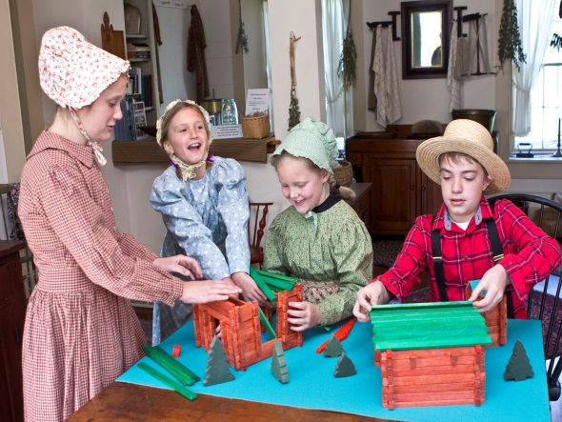 | The Clark’s first home was most likely a log house.  We invite you to come to the Clark House to learn how to construct a model log house and barn. From what materials is your home constructed?
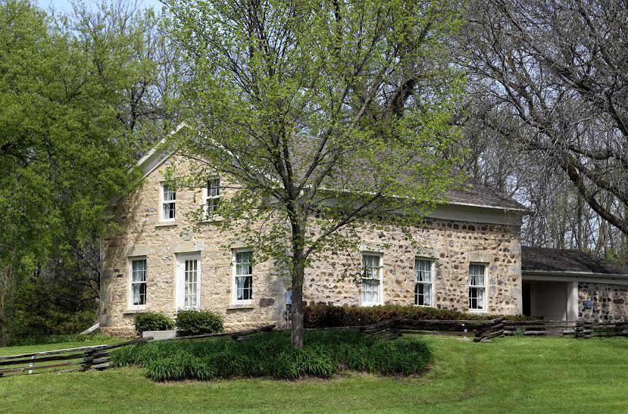 | The limestone Clark House on the corner of Bonniwell and Cedarburg Roads was built in 1848.  Why is 1848 an important date in Wisconsin history?
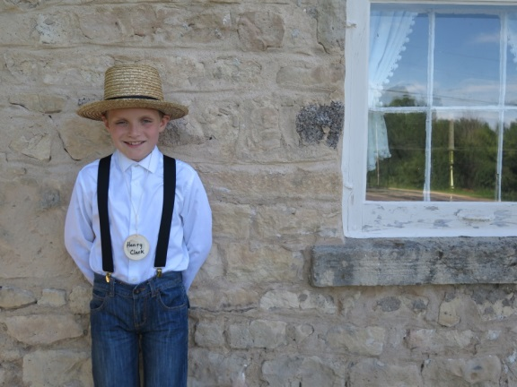 | Henry Clark  Can you imagine being the only boy of eight children? How many siblings do you have?
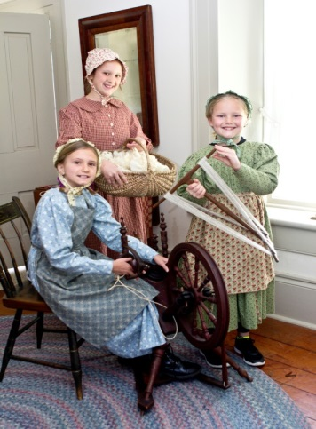 | The Clark Girls  The younger Clark girls, Elizabeth and Precious, learned skills such as weaving from their older sister Caroline. Do you have older siblings? If so, what have you learned from them?
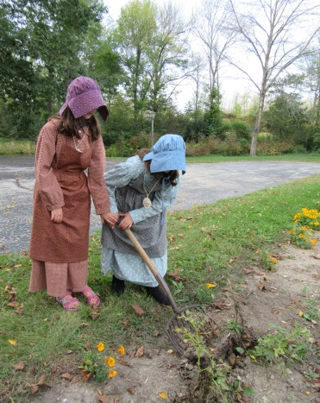 | Farm chores always included hoeing the potato patch  What chores do you have in your home and yard? Do you wear a bonnet or hat to keep cool in the hot summer sun?
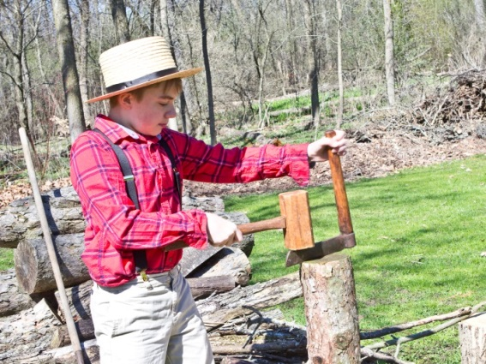 | Henry worked hard to make certain there was enough wood to keep the fireplace going throughout the night.  What fuel does your family use to heat your home? Does it involve any work on your part?
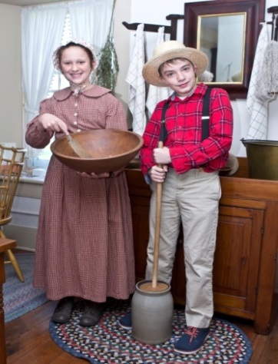 | Caroline and Henry worked together in the pantry  What are your daily or weekly chores around the house? Do you do chores with another family member?
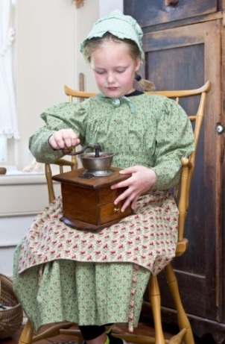 | Precious Clark enjoyed grinding coffee beans using a lap coffee mill  Does your family grind their coffee beans for their morning pot of coffee?
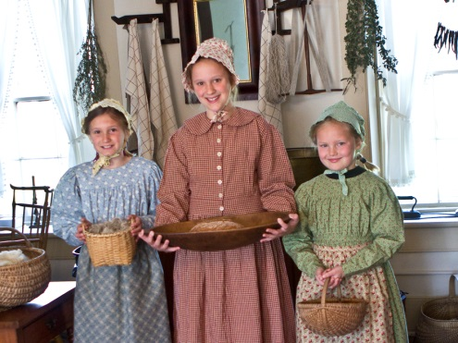 | The Clark girls happily did their special pantry chores  Do you like to do chores by yourself or with others?
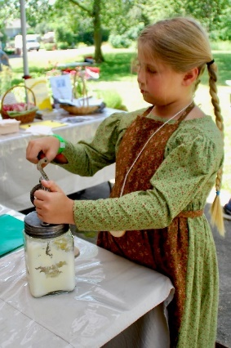 | Young Laura’s favorite chore was churning butter.  Does this look like fun to you?
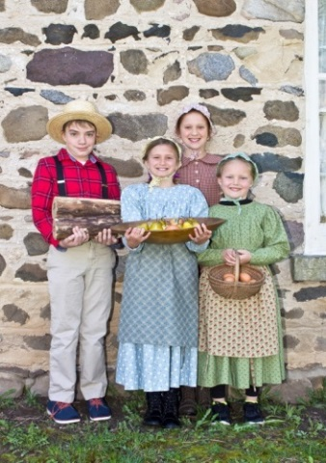 | Each Clark child did his or her part to help with chores  What chores did your parents have when they were your age?
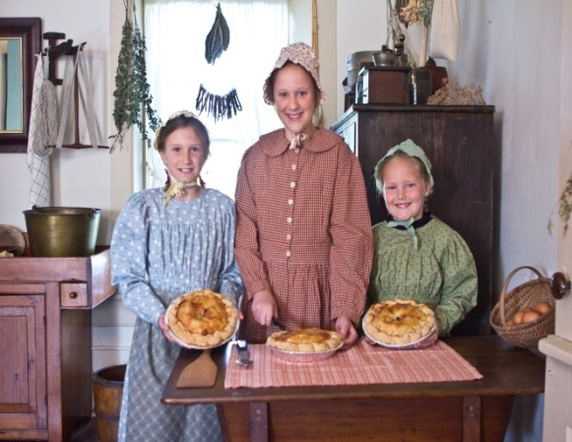 | With eight children, two parents and two hired men, these three fresh pies should be just about right.  Have you ever made a pie? What kind of pie do you like?
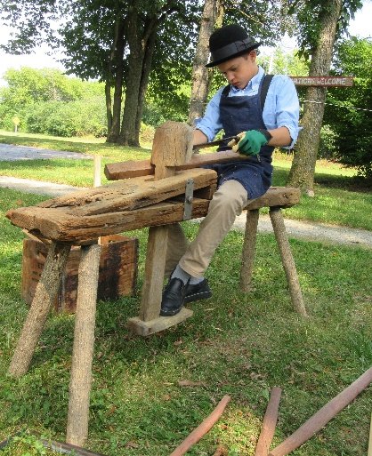 | Jonathan and the hired men taught young Henry more difficult skills such sitting on a wooden bench and making tool handles.  What is your most difficult chore? How did you learn it?
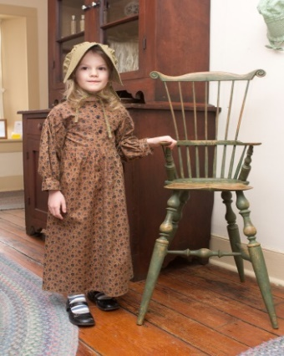 | With eight children the high chair was an important piece of furniture in the Clark keeping room  What piece of furniture does your family use the most?
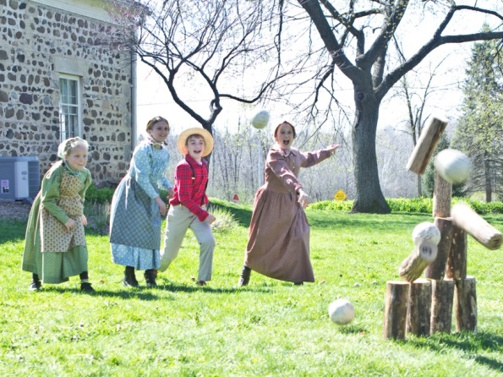 | The Clark children made up their own games such as this log toss game of skill  Have you made up any games?
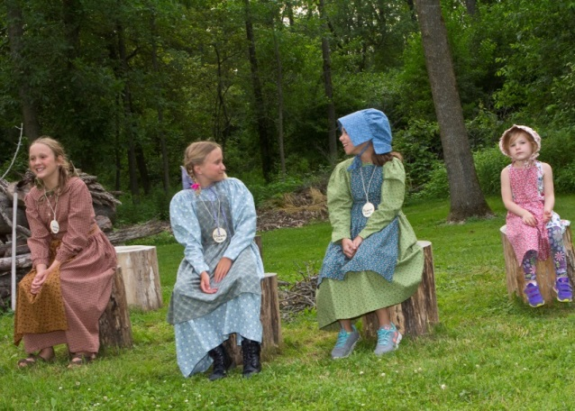 | The Clark girls had time to play games in the yard  What are your favorite outdoor games?
Take a tour of the Jonathan Clark House and step back to 1848
We will have costumes for you to wear as you “Think Like a Historian”
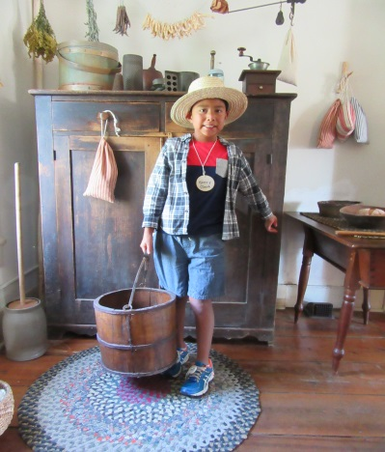 | As you tour you can try your hand at some of Henry’s daily chores.  Can you lift a heavy water bucket?
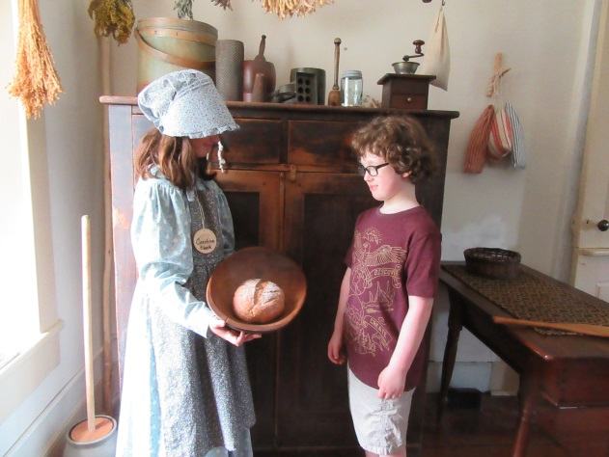 | Our young tour guides will tell you about the lifestyle of the Clark children.  How is their life different than yours? How is it the same?
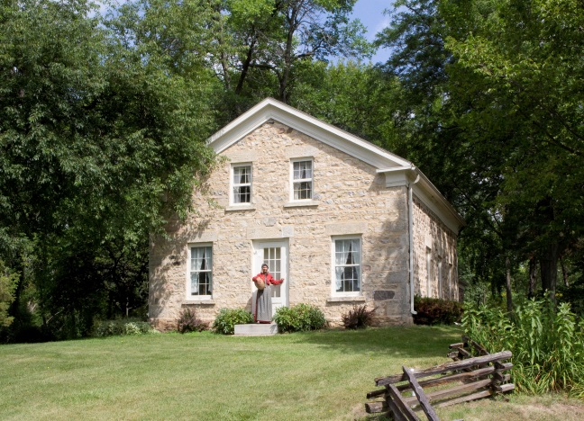 | Call us to set up a tour for you, your family and friends.  Jonathan Clark House Museum  Margaret Bussone, Education Director  Nina Look, Executive Director  Frederick Derr, Curator  P. O. Box 634, Mequon, WI 53092  jchmuseum@gmail.com  www.jonathanclarkhouse.org  262.618.2051

Thank you to our featured young historians who volunteer their time to teach others about the lifestyle of our early settlers.

Mission of the Jonathan Clark House:
To collect, preserve and share the history of the Jonathan Clark House
and the early settlers of Mequon-Thiensville.

